# (WS2015/16)

## Course Monitoring

### Task 1: Sensors (15%)

a) Inclinometers are used to monitor subsurface movements and deformations. One

typical example of the applications is determining the angle between the true

horizontal plane and the inclined plane. Please explain the measurement

principle of an inclinometer based on the pendulous system in a few sentences

and make a sketch for it. Give another measurement principle of inclinometer and

draw a sketch to explain it.

|  |
| --- |
| The measurement principle of the inclinometer based on the pendulous is the measurement of the angle w.r.t. gravity vector  .  Another principle is the liquid system, which is based in the reflection of some ray in the liquid surface: if the surface is totally horizontal, the ray’s incidence and reflection angles are the same (no deviations). |

b) Please give the typical accuracy of following measuring devices. Which of them may be defined as geotechnical sensors?

|  |  |  |  |
| --- | --- | --- | --- |
| **Total station:**  -Distances: 1 mm + 1 ppm  -Hz angles: 0.3 mgon  -V angles: 1 gon | **Extensometer**  -0.1 -1 mm | **Nadir optical plummet**  0.5 – 1 mm | **Precise levelling**  0.5 mm/km |

### Task 2: Measurement Concept (20%)

The Heinrich-Hertz Tower is a radio telecommunication tower in Hamburg, Germany. It was built through 1965 - 1968 and it is the tallest building in Hamburg with an overall height of 271.5 m. This tower, which could underlie movements, will be monitored using some different measurement techniques. Geodetic engineers had determined a critical deflection of 9 cm at the height of 125 m (a restaurant), which is significant greater than the limit of 3 cm for deflection of the tower. The movements decrease from the top of the tower to the foundation. Please design a measurement concept for the tower that is displayed in Figure 1, considering the condition for the resolution of the measurement system that dx = 1cm and following the detailed questions a) to f).

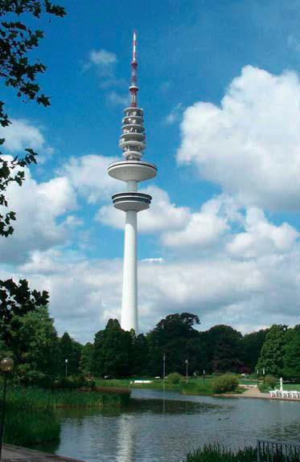

1. What are the three most likely types of deformations of the Heinrich-Hertz Tower? Please describe them with a sketch.

|  |
| --- |
|  |

1. What kind of reference system would you like to choose?

|  |
| --- |
| -2D Local reference system |

1. Please choose the measurement interval and give the sampling rate with the

expected movements below. Name possible causes for the expected periodic

movements.

|  |  |  |  |
| --- | --- | --- | --- |
|  | **Period of the deformation** |  | **Expected deflection** |
|  |  |  |  |
|  | *daily (24h), periodic* |  | max. 6 mm |
|  |  |  |  |
|  | *yearly (365 days) , periodic* |  | max. 15 cm |
|  | |  |  |

|  |
| --- |
| Measurement interval:  should be the double of the maximum expected deflection (2×15 cm=30 cm).  Sampling rate    A periodic movement could be the one influenced by the people going inside the restaurant at specific lunch times. |

1. Please define the measurement accuracy

|  |  |  |
| --- | --- | --- |
|  | **Daily**  Max = 0.6mm  Min = 0.12mm | **Annually**  Max= 1.5 cm  Min= 0.30 cm |

1. If the following measurement techniques were applied to monitor the Heinrich-

Hertz Tower, please explain their advantages and disadvantages with keywords.

|  |
| --- |
| 1. Precise levelling   Pros: Good accuracy: 0.5 mm/km  Cons: Not completely automatable |
| 1. Tachymeter   Pros: distances up to ca. 2km  Cons: strong influence of refraction |
| 1. Plumbing   Pros: good accuracy  Cons: Sighting distance up to 250m |
| 1. Inclination measurement   Pros: accuracy of 0.5 mgon  Cons: |

1. Please choose two most suitable measurement techniques from e), as well as

their corresponding measurement devices.

|  |
| --- |
| -Tachymeter 🡪 Total Station  -Plumbing 🡪 Mechanical plumbing |

### Task 3: Deformation Analysis (15%)

1. Please name the 4 deformation models and list the information about their modelling geometry, time-dependence and influencing forces in a table.

|  |  |  |  |
| --- | --- | --- | --- |
| **Model** | **Geometry (deformation)** | **Time** | **Forces** |
| Congruence | X | - | - |
| Static | X | - | X |
| Kinematic | X | X | - |
| Dynamic | X | X | X |

1. Within a given height network the heights of three points should be tested for movements. Please use the information on the next page and perform a test for localization of coordinate movements.

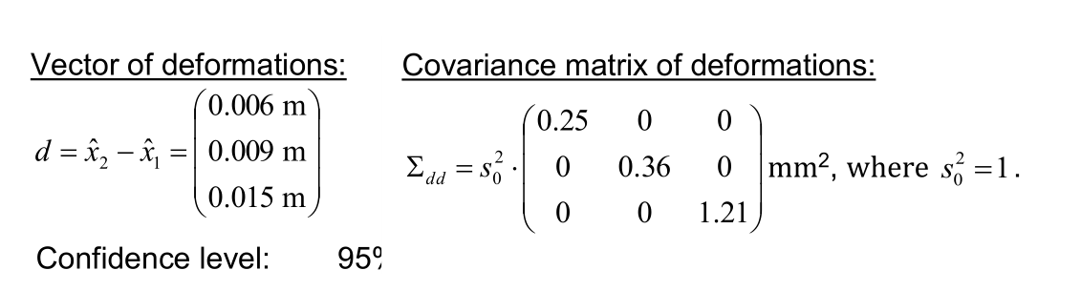



|  |
| --- |
|  |

## Course: Kinematic Measurement Systems

### Task 1: Robot Tachymeters (15%)

1. Please describe two different realizations for automatic rough pointing technique of tachymeters and name the corresponding manufacturer.

|  |
| --- |
| Rough pointing: recognition of target points without pre-information.  Finished if reflector is on telescope’s range of vision.  Realizations:   1. **Special sensors for rough pointing (Leica Powersearch)**   -Reflection is detected at tachymeter (passive reflector)  -Laser plane (α<= 110°)  -Horizontal rotation -> detect Hz angle (50 mgon accuracy)  -Vertical angle > use of laser beam (50-70 mgon accuracy)   1. **Use of Active reflectors (Trimble)**   -Laser plane (α=10°)  -Reflector transmits the signal back to the instrument via modulated laser or infrared signal.  -Reflector is uniquely identified. |

1. For an automatic fine pointing two different procedures are existing. Please name the two procedures and describe the main process steps. Give a sketch if necessary.

|  |
| --- |
| Fine pointing: determination of deviation between crosshair and reflector’s center.  Realizations:   1. **Image processing (Leica / Trimble)**   -Detection of transmitted (active reflector) or reflected (passive reflector) infrared light using LCD array at instrument.  -Reflector’s center is determined with center of gravity within image (no focus required).  *Center of reflector (X’ Y’)  *Transformation (X’ Y’) 🡪 (Hz V)  *Calculation of deviations (ΔHz ΔV)  *Correction of readings (Hz V)     1. **Time measurement (Topcon)**   -Range vision by automatic laser beam  -Δt between the start and finish of signal reflection is transformed into (ΔX’ ΔY’)  -(ΔX’ ΔY’) > (ΔHz ΔV) > Correction of readings (Hz V) |

1. For realization of target tracking in kinematic mode, 4 steps have to be performed. Please give a sketch and a short description on the 4 steps.

|  |
| --- |
|  |

### Task 2: Vehicle Models (20%)

1. What kind of simplifications are considered at the transition from a two-track vehicle model to one-track vehicle model (bicycle-model)?

|  |
| --- |
| **Simplifications**  - centre of gravity coincides with height of road (on the ground?)  - linear system is assumed  - wheels of rear axle and front axle are replaced by one wheel at a time |

1. Please draw a sketch of a front wheel steered bicycle model, moving with slow velocity on a circle. Depict the following variables:

|  |  |
| --- | --- |
|  | * Front steering angle (dA) * Slide slip angel at the centre of gravity (β0) * Distance between two axles (l) * Distance from rear axle to CG (lh) * Distance from front axle to CG (lv) * Center of gravity (SP) * Velocity of CG (V) * Velocity of rear wheel (Vh) * Velocity of front wheel (Vv) * Centre of circle (O) |

1. For a two-track crawler model the following incept theorem is given:

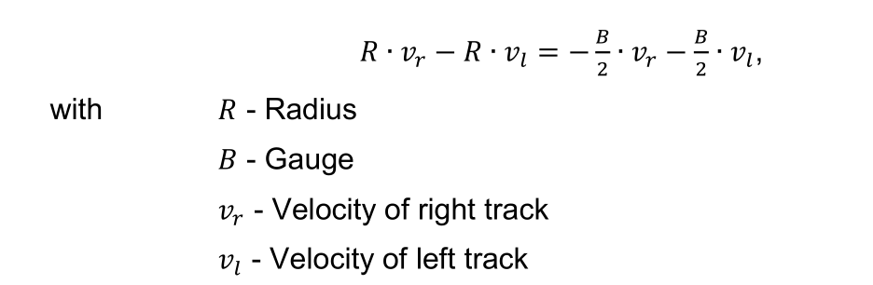

* Please give the relationship between the velocities *vr* and *vl*, and the curve directions (left hand curve, straight, right hand curve).

|  |
| --- |
| -Vr = Vl : straight line  -Vr > Vl : left hand curve  -Vr < Vl : right hand curve |

* Please calculate the radius of a left hand curve for a crawler with the given gauge of 1,80 m. The velocities are given as follows:
  + - * Left track: 5 m/s
      * Right track: 8 m/s

|  |
| --- |
| Sign indicates curve direction. |

### Task 3: Control of Moving Objects (10%)

1. What is the main task of the closed loop system?

|  |
| --- |
| Elimination of control deviation *e(t)* |

1. Please give a sketch of a detailed general closed-loop-system and name the

following variables: w(t), u(t), e(t), z(t), y(t)

|  |
| --- |
|  |

1. For the alignment of controllers different methods are existing. Please describe the principle steps of controller alignment according to “Ziegler and Nichols”. 🡪

|  |
| --- |
| -Closed-loop system is brought up to stability by increasing the amplification.  -P-controller is used as controller  -Proportional gain: Kp is small -  -Reset time: Tn 🡪 ∞  -Hold-back time: Tv 🡪 0  -Increase of Kp up to never-ending oscillation  -Kp-critic and T-critic can be determined as critical values for proportional gain and oscillating period |